CR  Local Resources  Bureau of Labor and Statistics  Occupational Outlook Handbook  Good Samaritan  Atlanta Mission  Georgia Gwinnett College  Catholic Charities  Worksource Atlanta  Self-Directed Search Transition-To-Work Inventory  riasec  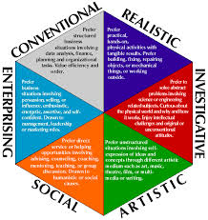  Career Assessment | Career Resources  Helpful career resources and local labor market information  Goal of career counseling  The goals of career counseling lies in helping students learn and identify their career interests, relate their interests and goals to opportunities, and correlate their goals to career plans and opportunities. Finally the counselor and client will evaluate the progress through academic preparation  National Standards for Students  Standard A: Students will acquire the skills to investigate the world of work in relation to knowledge of self and to make informed career decisions.  Develops Career Awareness/Develops Employment Readiness  Standard B: Students will employ strategies to achieve future career goals with success and satisfaction.  Acquire Career Information/Identify Career Goals  Standard C: Students will understand the relationship between personal qualities, education, training, and the world of work.  Acquire Knowledge to Achieve Goals/Apply Skills to Achieve Career Goals  ASCA Standards for Career Development  School counselors are often the first helping professionals involved within a clients job and career choices. However, as one continues in higher educational institutions the need for school directives surrounding job and career placement remains a pivotal component. School counselors ensure a compliance with district initiatives, state directives, and student standards. Further the ASCA Ethical Standards for School Counselors aids in upholding integrity and professionalism. In addition, they aid in guiding the counselors decision making process and practies for both school counselor and students.

